USER MANUAL
FOR
EMERGENCY CREDIT LINE GUARANTEE SCHEME 5.0 (ECLGS 5.0)

Table Of Content
1. Portal Access 2
2. Login Process for MLI Maker 2
Step 1: Open Login Page 2
Step 2: Enter Login Credentials 3
Step 3. Navigation to Application Lodgement 3
Navigation Path: 3
Step 4: Guarantee Lodgement Bulk Upload Process 4
Step 5: Viewing Uploaded File Status 5
3. Login Process for MLI Checker 6
Step 1: Open Login Page 7
Step 2: Navigation to Reports & MIS 7
Step 3: File Download Process 8
Step 4: Re-upload of File by MLI Checker 8
Step 5: Verification of Re-uploaded File Status by MLI Checker 9

Portal Access
The access to the ECLGS application has been provided to all users through the link provided on official portal of NCGTC i.e., www.ncgtc.in

2. Login Process for MLI Maker
To access the ECLGS 5.0 application, the MLI Maker shall perform the following steps:

Step 1: Open Login Page
Navigate to the ECLGS portal login screen.

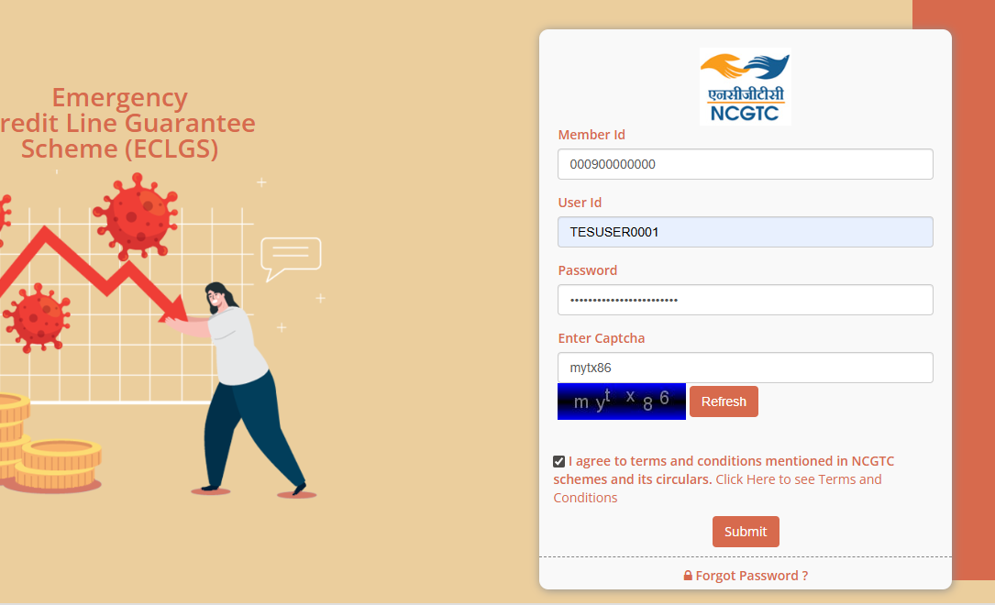

Step 2: Enter Login Credentials

The following details are required to log in:
1. Enter Member ID
2. Enter User ID
3. Enter Password
4. Enter Captcha
5. Check the checkbox to Agree Terms and Condition
6. Click on ‘Submit’ button
Forgot Password
1. Click Forgot Password
2. Enter Hint Answer
3. Click on Save
4. You will Received email on register email ID
Upon successful authentication, the user shall be redirected to the ECLGS application Home Page.
Step 3. Navigation to Application Lodgement

After successful login, the MLI Maker shall navigate to the bulk upload section using the following path:

Navigation Path:
Application Processing → Application Lodgement

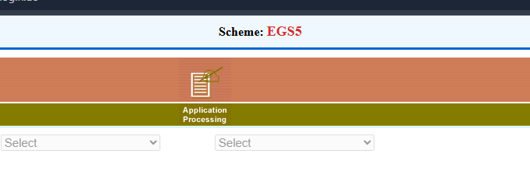
The user shall then select Application Lodgement Then “Guarantee Lodgement Bulk Upload”
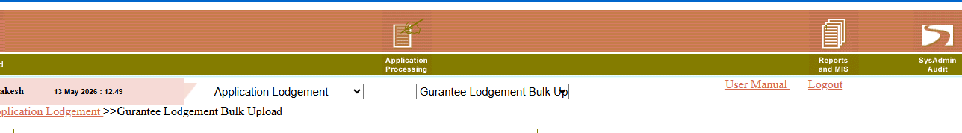
Upon selection, the bulk upload screen shall be displayed.

Step 4: Guarantee Lodgement Bulk Upload Process

The MLI Maker can upload Guarantee Lodgement data in bulk through the upload functionality available in the portal.
Before proceeding for the file upload MLI Maker to follow the instructions given for preparation of the input file and keep it ready. The required details are available on NCGTC’s website under ECLGS 5.0 scheme page as well as on the home page of ECLGS application.
Steps for Uploading the File:
Step 1:
Click on the “Choose File” button.
Step 2:
Select the prescribed bulk upload file from the local system.
Step 3:
Check box to be selected to accept the management certificate provided on the page. Click on the “Upload” button to initiate the upload process.

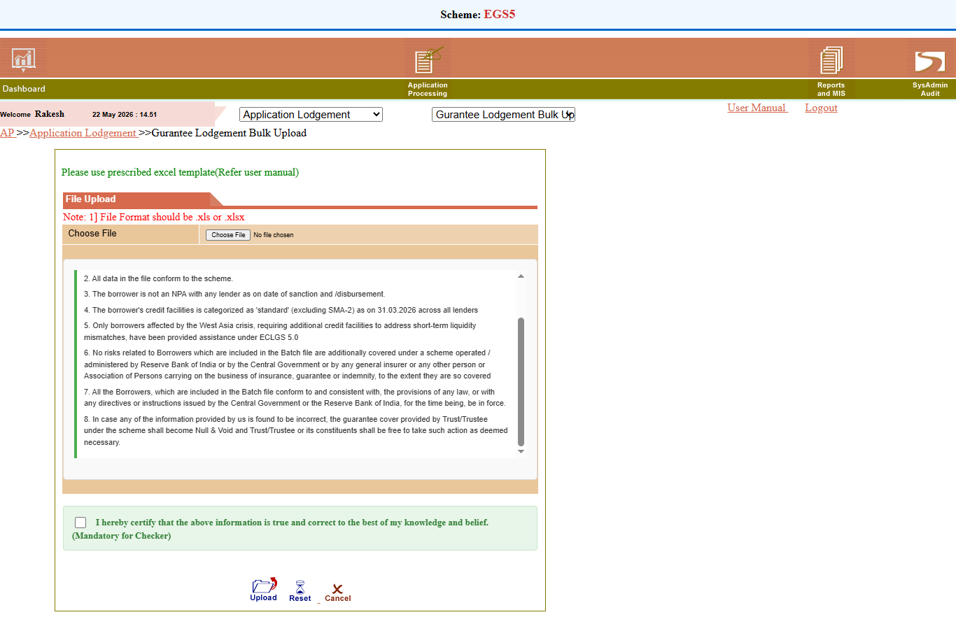

Step 4:
Upon successful upload, the system shall display a confirmation or success message on the screen.

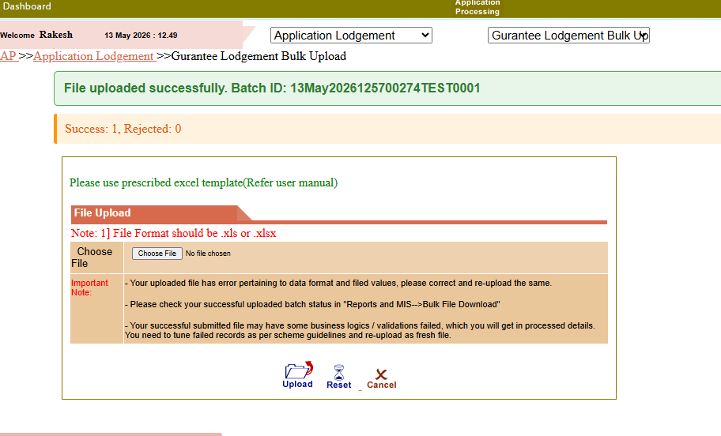

Step 5: Viewing Uploaded File Status
After uploading the file, the MLI Maker can verify the processing status of the uploaded file through the Reports & MIS section.
Navigation Path:-
Reports & MIS → Bulk File Download
Under the Category dropdown, select “Sanction Maker Bulk File Status”
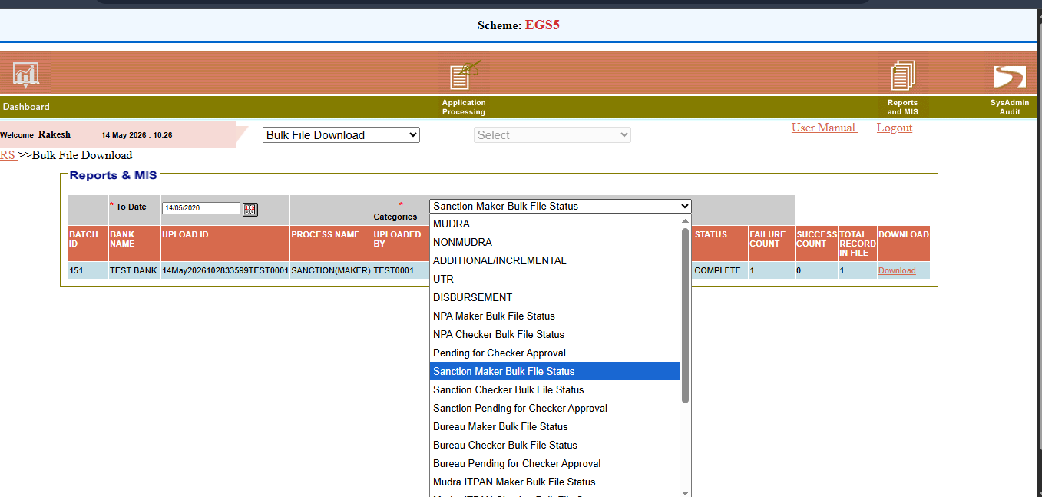

The system shall display the list of uploaded files along with their processing status.
The uploaded file status screen enables the MLI Maker to:
- View uploaded file details
- Check processing status
- Download processed/error files
- Identify validation or data errors
- Correct erroneous records
- Re-upload corrected files
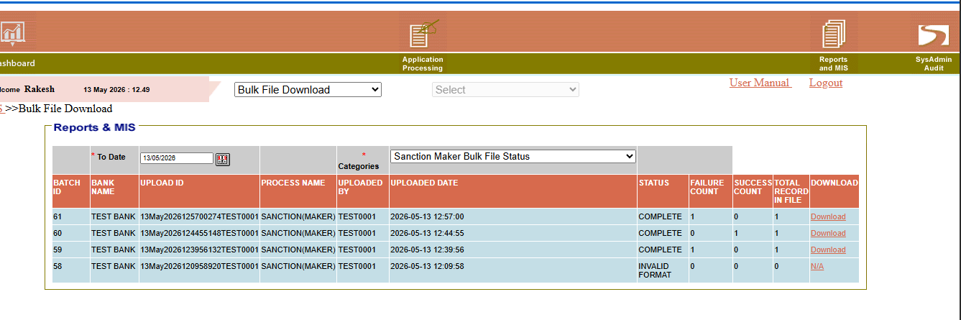

If any records fail during validation, the user may download the error file, rectify the identified issues, and upload the corrected file again.

Login Process for MLI Checker

Step 1: Open Login Page
Navigate to the ECLGS portal login screen.
Step 2: Navigation to Reports & MIS
After successful login, the MLI Checker shall select the Bulk Download option from the dropdown menu.
Path: Reports & MIS tab → Bulk Download option
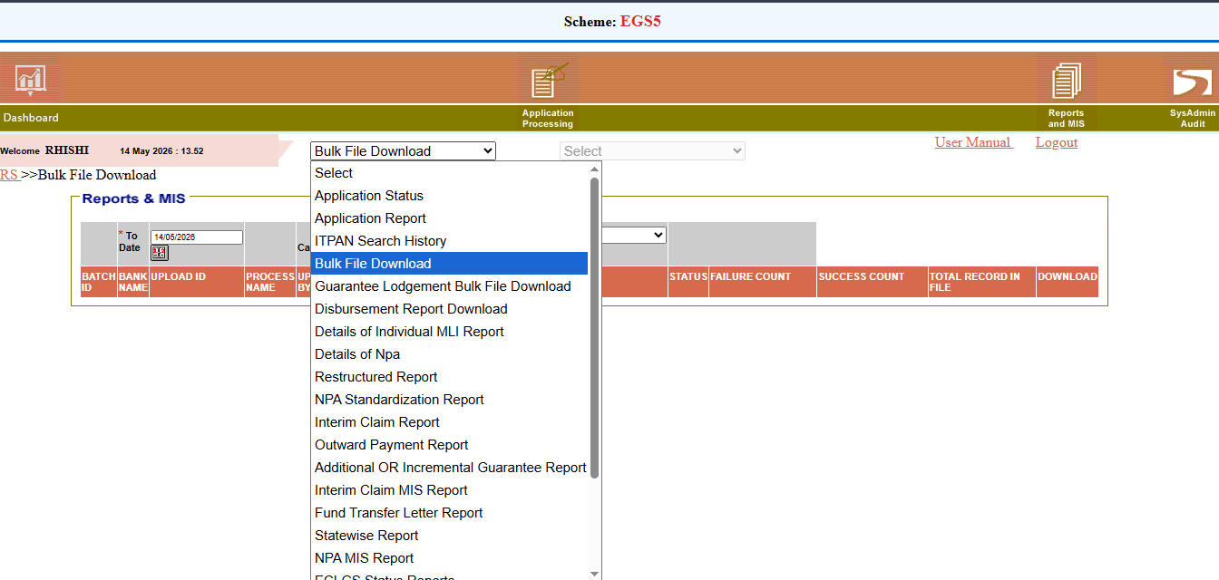

Step 3: File Download Process
The user shall select the Sanction Pending for Checker Approval option from the Categories dropdown menu.
The user can download the file displayed on the screen and update the downloaded Excel sheet by adding the Checker Status and Checker Remarks in the respective columns.
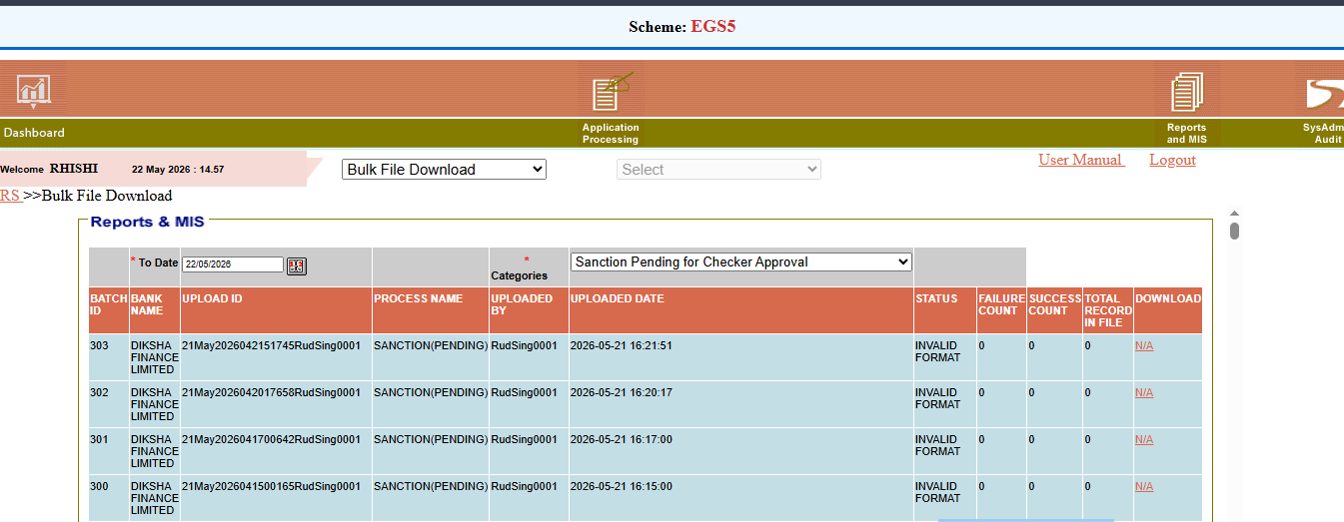

Step 4: Re-upload of File by MLI Checker
The MLI Checker shall re-upload the file after updating the Checker Status and Checker Remarks by navigating through the following path:
Path: Application Processing → Application Lodgement → Guarantee Lodge Bulk Upload

Step 5: Verification of Re-uploaded File Status by MLI Checker
The MLI Checker can view the re-uploaded sanction file by navigating through the following path:
Path: Reports & MIS → Bulk File Download
- Under the Categories dropdown menu, the user shall select the Sanction Checker Bulk File Status option.
- The MLI Checker can then verify the status of the uploaded file on the UI screen.
